% Simulation of a continuous dynamic system described by ordinary
% differential equations.
%
% INITIAL SEGMENT
%
% Define constant model parameters as global variables. Set the initial
% conditions of the states and set up the input to the model.
%
% It is good practice to clear the MATLAB workspace at the beginning of
% a program
clear all
clc
% Define and initialise the model input and any model parameters
% as global variables so that they can be read in the function model.m.
global Vd L R Kt Ke bs Jm Jw Kc KH KN KS KV KY VT Rw Rm Gc KI siref
Vd = 2;
L = 0.1;
R = 4;
Kt = 0.35;
Ke = 0.35;
bs = 0.01;
Jm = 0.002;
Jw = 0.0011;
Kc = 2.2;
KH = 2.2;
KN = 14.14;
KS = 9.81;
KV = 0.466;
KY = 29.94;
VT = 0.75;
Rw = 0.064;
Rm = 0.124;
Gc = 33.3;
KI = 0;
siref = 0.785398;
% Define parameters for the simulation
stepsize = 0.001; % Integration step size
comminterval = 0.001; % Communications interval
EndTime = 100; % Duration of the simulation (final time)
i = 0; % Initialise counter for data storage
% Initial conditions of all states and state derivatives
x = [0,0,0,0,0,0,0,0,-0.174533]';
xdot = [0,0,0,0,0,0,0,0,0]';
int = 0;
Time = [0,8,16,32,48,57,70,75,84,93,100];
Vel = [0.75,0.81,0.85,0.9,0.75,0.62,0.68,0.76,0.87,0.81,0.88];
% Generate the z values for the spline
count = numel(Time);
z(1) = 0;
for n = 2:1:count
z(n) = -z(n-1)+2*((Vel(n)-Vel(n-1))/(Time(n)-Time(n-1)));
end
% END OF INITIAL SEGMENT - all parameters initialised
%
% DYNAMIC SEGMENT
%
% The DYNAMIC SECTION is the main section of a simulation program. This is
% evaluated for every time interval during the simulation. Therefore it is
% an interative process.
for time = 0:stepsize:EndTime,
% store time state and state derivative data every communication interval
if rem(time,comminterval)==0
i = i+1; % increment counter
tout(i) = time; % store time
xout(i,:) = x; % store states
xdout(i,:) = xdot; % store state derivatives
end % end of storage
% Equation for the quadratic spline
if time >= 0 && time < 8
Vt = ((z(2)-z(1))/(2*((Time(2)-Time(1))))*(time-Time(1))^2+z(1)*(time-Time(1))+Vel(1));
elseif time >= 8 && time < 16
Vt = ((z(3)-z(2))/(2*((Time(3)-Time(2))))*(time-Time(2))^2+z(2)*(time-Time(2))+Vel(2));
elseif time >= 16 && time < 32
Vt = ((z(4)-z(3))/(2*((Time(4)-Time(3))))*(time-Time(3))^2+z(3)*(time-Time(3))+Vel(3));
elseif time >= 32 && time < 48
Vt = ((z(5)-z(4))/(2*((Time(5)-Time(4))))*(time-Time(4))^2+z(4)*(time-Time(4))+Vel(4));
elseif time >= 48 && time < 57
Vt = ((z(6)-z(5))/(2*((Time(6)-Time(5))))*(time-Time(5))^2+z(5)*(time-Time(5))+Vel(5));
elseif time >= 57 && time < 70
Vt = ((z(7)-z(6))/(2*((Time(7)-Time(6))))*(time-Time(6))^2+z(6)*(time-Time(6))+Vel(6));
elseif time >= 70 && time < 75
Vt = ((z(8)-z(7))/(2*((Time(8)-Time(7))))*(time-Time(7))^2+z(7)*(time-Time(7))+Vel(7));
elseif time >= 75 && time < 84
Vt = ((z(9)-z(8))/(2*((Time(9)-Time(8))))*(time-Time(8))^2+z(8)*(time-Time(8))+Vel(8));
elseif time >= 84 && time < 93
Vt = ((z(10)-z(9))/(2*((Time(10)-Time(9))))*(time-Time(9))^2+z(9)*(time-Time(9))+Vel(9));
elseif time >= 93 && time < 100
Vt = ((z(11)-z(10))/(2*((Time(11)-Time(10))))*(time-Time(10))^2+z(10)*(time-Time(10))+Vel(10));
end
Vt_array(i) = Vt; % Store velocities in an array
% DERIVATIVE SECTION
%
% The DERIVATIVE SECTION contains the statements needed to evaluate the
% state derivatives - these statements define the dynamic model (model.m)
int = int + (stepsize*((Kc*siref)-(KH*x(9))));
deltav = (Gc*((siref*Kc)-(KH*x(9)))) + (int*Gc*KI);
Vin(1) = Vd - deltav;
Vin(2) = Vd + deltav;
xdot = state_space_model(x,Vin);
% END OF DERIVATIVE SECTION
%
% INTEG SECTION
%
% Numerical integration of the state derivatives for this time interval
x = rk4int('state_space_model', stepsize, x, Vin);
% END OF INTEG SECTION
end
% END OF DYNAMIC SEGMENT
%
% TERMINAL SEGMENT
%
% The TERMINAL SEGMENT contains statements that are executed after the simulation
% is complete e.g. plotting results
figure(1) % define figure window number
subplot(5,2,1) % select the first subplot
plot(tout,xout(:,1),'b-') % plot state 1 against time
xlabel('time [s]') % label x-axis
ylabel('Left current [A]') % label y-axis
grid on % turn grid on
subplot(5,2,2) % select the second subplot
plot(tout,xout(:,4),'b-') % plot state 4 against time
xlabel('time [s]') % label x-axis
ylabel('Right current [A]') % label y-axis
grid on % turn grid on
subplot(5,2,3) % select the third subplot
plot(tout,xout(:,2),'b-') % plot state 2 against time
xlabel('time [s]') % label x-axis
ylabel('Left motor rot [rad/s]') % label y-axis
grid on % turn grid on
subplot(5,2,4) % select the forth subplot
plot(tout,xout(:,5),'b-') % plot state 5 against time
xlabel('time [s]') % label x-axis
ylabel('Right motor rot [rad/s]') % label y-axis
grid on % turn grid on
subplot(5,2,5) % select the fifth subplot
plot(tout,xout(:,3),'b-') % plot state 3 against time
xlabel('time [s]') % label x-axis
ylabel('Left wheel rot [rad/s]') % label y-axis
grid on % turn grid on
subplot(5,2,6) % select the sixth subplot
plot(tout,xout(:,6),'b-') % plot state 6 against time
xlabel('time [s]') % label x-axis
ylabel('Right wheel rot [rad/s]') % label y-axis
grid on % turn grid on
subplot(5,2,8) % select the eighth subplot
plot(tout,xout(:,8),'b-') % plot state 8 against time
xlabel('time [s]') % label x-axis
ylabel('Sway velocity [m/s]') % label y-axis
grid on % turn grid on
subplot(5,2,7) % select the seventh subplot
plot(tout,xout(:,7),'b-') % plot state 7 against time
xlabel('time [s]') % label x-axis
ylabel('Yaw rate [rad/s]') % label y-axis
grid on % turn grid on
subplot(5,2,9) % select the nineth subplot
plot(tout,xout(:,9),'b-') % plot state 9 against time
xlabel('time [s]') % label x-axis
ylabel('Yaw angle [rad/s]') % label y-axis
grid on % turn grid on
figure(2)
plot(tout,Vt_array,'b-')
hold on
plot(Time,Vel,'r-')
xlabel('Time(s)')
ylabel('Forward Velocity(m/s)')
grid on
% END OF TERMINAL SECTION
% END OF SIMULATION PROGRAM
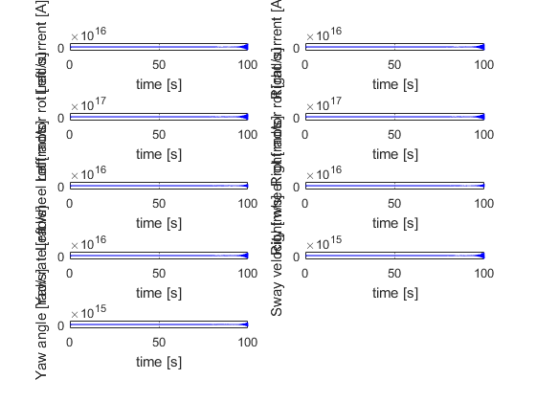
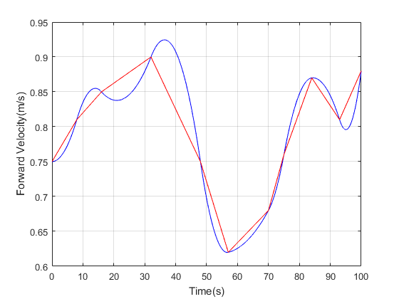
Published with MATLAB® R2016a

